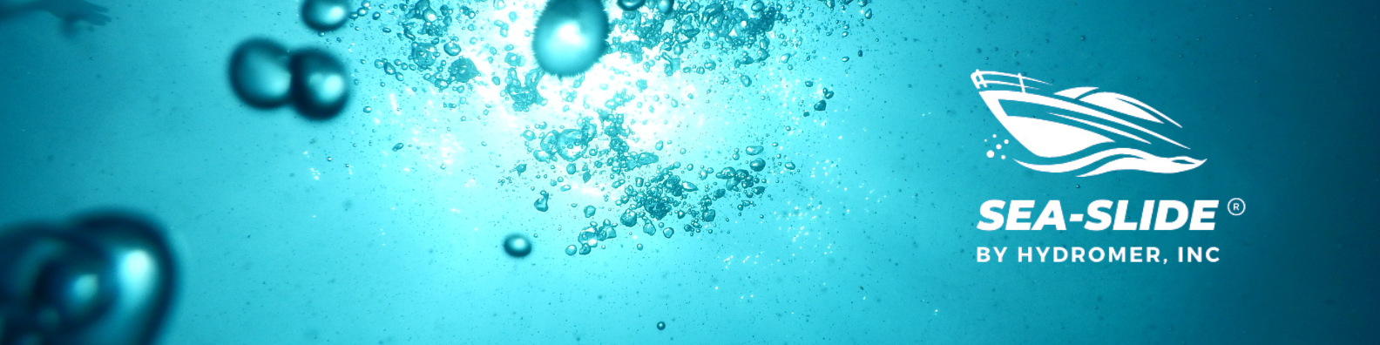
Hydromer Inc.
4715 Corporate Dr. NW
Concord, NC 28027

Dear Mr. Gumpert:
As I told you in our phone conversation, your product, Sea-Slide, definitely works and works quite well. Listed below are some of the statistics that we have found to date.
CRUISE SPEED (KNOTS)
RPM's | BEFORE SEA-SLIDE | AFTER SEA-SLIDE | % IMPROVEMENT
2200 | 14.5 | 16.5 | 13.8
2450 | 17.0 | 20.0 | 17.6

These times are LORAN recorded averages based on extensive running times. They would, therefore, include various sea and weather conditions. The subject boat was a Fortier 26 (Semi-displacement time hull).
An incidental point worth noting is our trip from Staten Island, N.Y. to Montauk harbor has consistently taken eight to nine hours. These runs have almost always been in relatively calm waters. This year the trip was completed in seven hours (minimum 12.5% improvement). The seas on this trip were also somewhat rougher than normal (15-20 knot following sea). Fuel consumption for this trip was slightly less than average.
I tend to believe it would have been a lot better if the sea conditions were more favorable. In support of this opinion, subsequent fishing trips from Montauk have shown average fuel consumption to be about 2.5 mpg as compared to 2.2 mpg prior to using Sea-Slide (12% savings).
As you can see, your product has shown initial success. My only outstanding concerns are whether the coating will still be as effective by October or November and if the repainting of the bottom next spring will present any problems (a lot of extra work).
I have enclosed my receipt for your consideration. Thank you for a very fine product.

