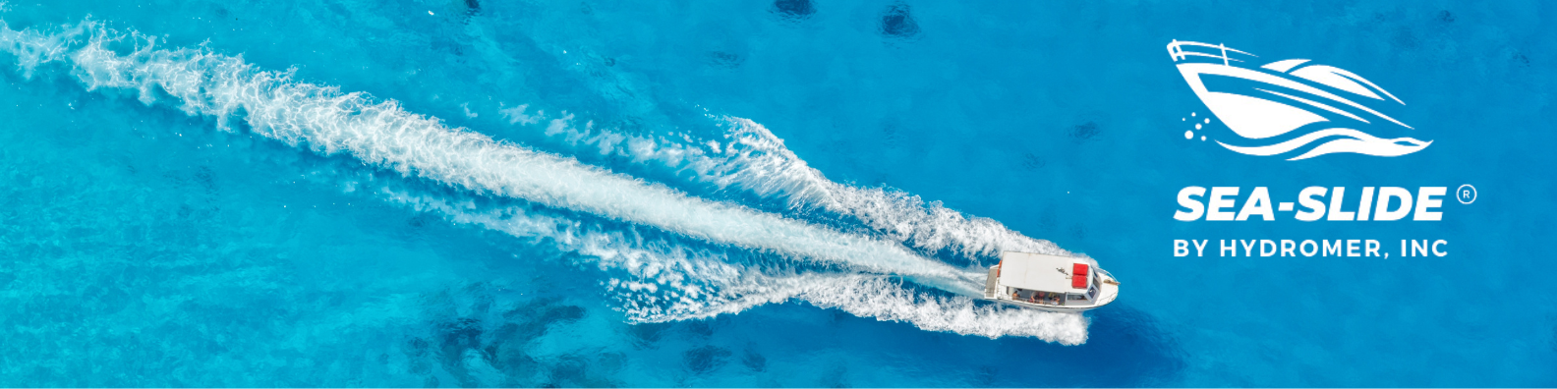
The University of Rhode Island, Kingston, Rhode Island 02881-0814 College of Engineering, Department of Ocean Engineering (401) 792-2273

REPORT OF DRAG TESTS USING SEA-SLIDE DRAG REDUCING PAINT
Second set of tests Planning Hull Model
INTRODUCTION
The August drag tests on a model of a merchant-type displacement hull did not produce clear results between the hull without and with the Sea-Slide paint. It was decided to use a planning type of hull in the second set of tests. The model was supplied by Hydromer, Inc. and was about 30 inches long.
TESTS
The tests consisted of a series of runs at different speeds and the drag forces on the hull were measured by an electronic dynamometer. During the tests, the model was free in pitch and heaven. The dynamometer was calibrated by known weights that exerted a pull in the drag direction.
The speed was measured by timing the passage of the towing carriage over a distance of 10 feet using an electronic timer.
The model was equipped with a 0.060-inch diameter trip wire located at approximately 5% of LWL aft of FP.
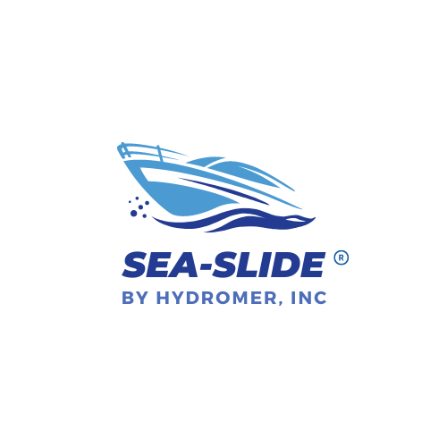
Precautions were taken to run each test under identical conditions and at a steady speed during the drag measurements.
Two sets of tests were run.
- model with standard anti-fouling paint
- model with Sea-Slide paint applied over the anti-fouling paint
RESULTS
1. Anti-fouling paint only
(calibration 0.477 lbs/in)
Speed | fps | 2.52 | 3.88 | 4.55 | 5.00 | 3.24 | 5.00 | 3.92 | 3.27
Drag | lbs | 0.38 | 1.12 | 2.05 | 2.86 | 0.76 | 2.84 | 1.24 | 0.76

4.63 | 4.88 | 3.61 | 4.98 | 4.65 | 4.88 | 4.95 | 4.83 | 4.98
2.15 | 2.58 | 0.91 | 2.86 | 2.34 | 2.67 | 2.86 | 2.67 | 2.91

2. Sea-Slide over the anti-fouling (calibration 0.449 lbs/in)
Speed | fps | 4.95 | 4.67 | 4.67 | 4.35 | 4.54 | 4.81 | 4.93 | 4.67
Drag | lbs | 2.42 | 1.93 | 1.98 | 1.39 | 1.75 | 2.18 | 2.33 | 2.02

5.00 | 4.63 | 4.97
2.58 | 1.93 | 2.51

Drag reduction values.
Speed, fps | 4.35 | 4.54 | 4.63 | 4.67 | 4.81 | 4.93 | 4.95 | 4.97 | 5.00
Drag change | 0.27 | 0.30 | 0.22 | 0.31 | 0.30 | 0.42 | 0.44 | 0.39 | 0.27
% change | 16 | 15 | 10 | 13 | 12 | 15 | 15 | 13 | 9

The above drag test results were plotted and are shown in Fig.1.

DISCUSSION OF RESULTS
The results of the drag tests, as shown in Fig.1, define two distinct curves. One for the model with anti-fouling paint only and the other with Sea-Slide over the anti-fouling paint.
The Sea-Slide paint indicates drag reductions of approximately 9% to 16% below the anti-fouling painted hull. It is therefore concluded that the Sea-Slide paint reduces the overall drag of the hull by a clearly measurable value.

RECOMMENDATIONS
The results of the above tests clearly indicate that the overall drag of a hull moving through water is affected by the application of the Sea-Slide paint.
Further investigations would have to be conducted to determine the actual mechanism of drag reduction due to the paint.


G. Kowaldli
T.Kowalski, Professor of Ocean Engineering
University of Rhode Island

